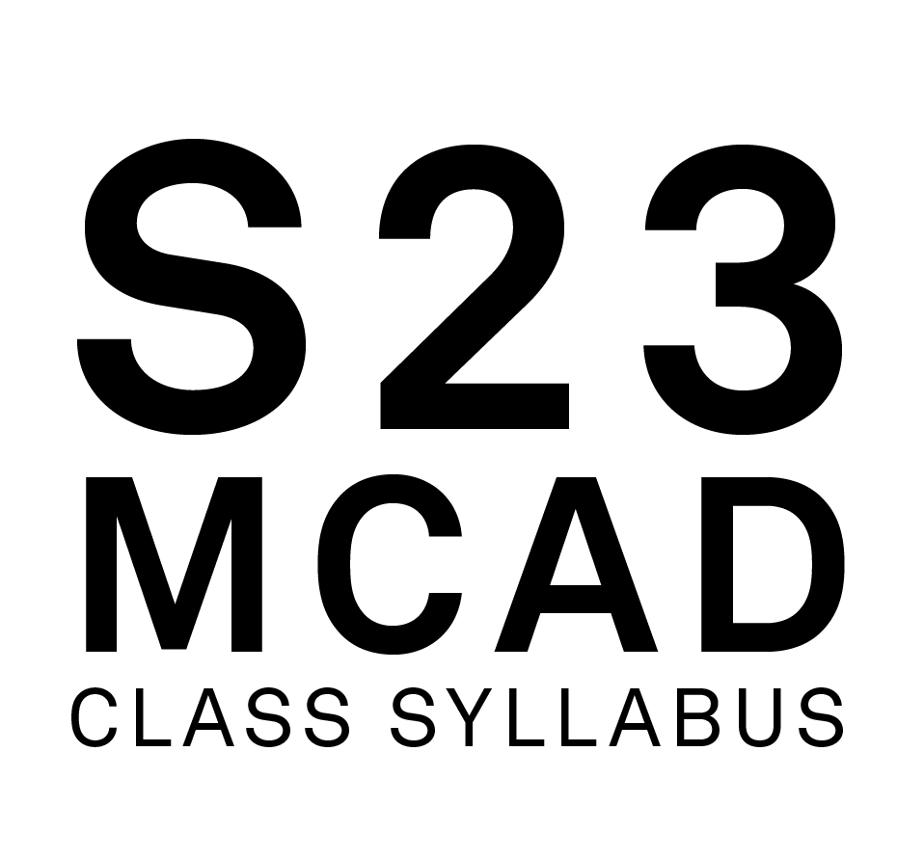

**Course Name:** Foundation: Media 2

**Course Number:** FDN 1312 03

**Class Meets:** F,

1:00 PM - 6:00 PM,

01/17/23 - 05/09/23

**Class Google Meet Link:** meet.google.com/zmo-nqbi-mnh

**Classroom:** Main303

**Faculty Name:** Severns, Benjamin

**MCAD Email Address:** ben_severns@mcad.edu

**MCAD Telephone Number, Academic Affairs:** 612-874-3694

**Online Office Hours:** Thursday - 1130-1230, Friday - 1130-1230

**Office Google Meet Link:** meet.google.com/jya-vgnc-iob

**FACULTY BIOGRAPHY:**

Ben Severns is an interdisciplinary artist whose studio work is concerned with the spectacular. The media that his studio produces include filmmaking, photography, robotics, freelance writing, industrial music, software, and sculpture. In addition to having taught in both the Fine Arts, Media Arts, and Foundations departments at the Minneapolis College of Art and Design, Severns also holds an adjunct position at Augsburg University where he teaches courses in New Media and Web Design.  
 His work has been exhibited throughout the United States and internationally, including at Boston University, the Institute of Contemporary Art (Maine), the Science Museum of Minnesota, the Minneapolis Institute of Art, and Public Functionary Gallery. Pieces of his work are held in private collections in Australia, Brazil, and the United States. He currently performs as "BS" to industrial-noise nights at local/regional venues and operates as an autonomous member of the "Chaos Combat Marching Band" and "Death By Selfie" while he works on rebuilding his home/studio in North Minneapolis.

**COURSE DESCRIPTION:**

Building on the knowledge acquired in Foundation: Media 1, this course engages students' skills in observation, recording, editing, critical analysis, and conceptualization within media arts. Through discussions, lectures, and creative projects, students explore various modes of media presentation and the power of moving images and multimedia work. Using digital technologies to deepen their media and technology foundation, students explore complex concepts and techniques for creating impactful work. Prerequisite: Foundation: Media 1

**OUTCOMES:**

Distinguish the appropriate application of concepts in media art production.   
Operate processes in recording technology.  
Edit digital material using skills and workflows.  
Apply creative coding applications and techniques.  
Articulate concepts and techniques through class critique.

**METHODOLOGIES:**

Lectures, Demonstrations, Discussions, Readings, Research/Analysis, Screenings, Class Exercises, Breakout Groups, Individual Projects, Group Projects, Case Studies, Writing Assignments, Written Proposals, Field Trips, Individual/Class Critiques

**REQUIRED TEXTBOOKS. READINGS AND WEBSITES:**

- all required readings will be supplied by the instructor -

**LIBRARY RESERVE INFORMATION:**

- none at the time of writing -

**MATERIALS AND TOOLS LIST:**

Projects will demand a number of software  
MCAD-issued MacBook Pro [or equivalent] with current lab build.  
  
Video camera  
Digital still camera  
SD Memory cards for ^^^^  
  
External digital storage/archive device [HARD DRIVE - HDD/SSD] - You will run out of room on school-issued computers sooner or later and there is no better time to get into the habit of backing up than yesterday.  
  
*We'll talk more about gear as it comes up this term - I take pride in being able to make due with what I can find/is available rather than exclusively needing the "finest" [$$$] equipment to own personally, and still returning excellent quality results. There will be bookmarks!

**CANVAS:**

https://mcad.instructure.com/courses/3533

**COURSE CALENDAR:**

**CLASS_1 [1/20/23]**  
Hello!  
Syllabus/Critique/Class roles

**Unit 1: AfterEffects &Digital Materiality**

Premiere Refresher Demo - nonlinear editing in a nutshell+tricks  
Studio-Generative Storytelling Exercise  
**Unit 1, part A assigned - To tell a story**  
**CLASS_2 [1/27/23]**  
AfterEffects software demo 1: software intro, compositions, partnering with Premiere [1A base-raw footage due by 230pm today!]

Studio Lighting Demo  
**Unit 1, part B assigned - Masking Makes Perfect**  
  
**CLASS_3 [2/3/23]**  
AfterEffects software demo 2: Masking, Mutual Animation, Text, Motion-Blur,  
**1A in-progress small-group critique**

Lighting the world demo1-1 meetings  
  
**CLASS_4 [2/10/23]  
1B in-progress demos**

**CLASS_5 [2/17/23]**  
**2A in-class workshop**

**Unit 2: I ain’t afraid of no glitch**  
**Unit 2, part A assigned - Glitch artifacts  
Unit 2, part B - Glitch-Media Installation assigned**  
**CLASS_6 [2/24/23]**  
**2A discussions**1-1 meetings  
  
**CLASS_7 [3/3/23]**

**Unit 3: Something immaterial that we hold as evidence of an adventure  
Unit 3, part A - in-class mapping exercise**  
  
**CLASS_8 [3/10/23]**  
**Unit 2, part B installation/critiques discussion -   
What about these groups? Who doesn’t have a plan? What do we need to move forward?**

3A part 2 workshop - **RobotRobot**

**Unit 5: Hot/Cold**

**Unit 5, part A assigned - a wild idea**

[~~~mid-semester break~~~]

**CLASS_9 [3/24/23]  
Unit 3, part B assigned**

**3B in-class workshop -** High Resolution Document scanning, your improvised map, p5js, and making the world out of nothing1-1 meetings  
  
**CLASS_10 [3/31/23]**  
**3B check-in small-group reviews  
Unit 3, part C - Minneapolis Skyway Field Research/Content Gathering  
Unit 5, part A - A real television show pitch conversation**  
**CLASS_11 [4/7/23]**  
Unit 3, part D - p5js travel-mapping website studio day!  
  
**CLASS_12 [4/14/23]**  
**Unit 3, part D critique**

**Unit 4: Collective Action to Actively Deny Our Dependence on Digitalis**  
1-1 meetings  
  
**CLASS_13 [4/21/23]**  
**Unit 4, part A - Media Fast** field trip/in-class exercise  
  
CLASS_14 [4/28/23]  
-studio day-  
  
**CLASS_15 [5/5/23]**  
**Unit 5, part B Show/Critique**

**Unit 5, part C due before 6pm**So long, and thanks for all the fish!

**EMAIL USAGE:**

Email is used at MCAD as the official means of communicating with the student body. Official college announcements regarding policy, classes, registration, deadlines, etc. are delivered via email. Students are expected to check their MCAD email frequently and are held responsible for all official information communicated to them via the email system. Misuse or misrepresentation of official communications by students will result in disciplinary action.

**ATTENDANCE POLICY:**

**In-Person, Online Synchronous and HyFlex**

The MCAD community aims to foster engaged and meaningful learning experiences and a collaborative environment to promote academic success in all classrooms, whether Online, HyFlex or In-Person. MCAD is committed to creating a space of belonging and care so that students are supported and are able to participate fully in class. Full participation includes active engagement with course materials, the timely submission of assignments, and attendance at all class sessions.

**Any absences, tardiness, or late assignments can result in the lowering of one's grade, at the discretion of the faculty.** It is particularly important that students attend the first meeting of all courses whether Online, In-Person, or HyFlex; failing to attend the first class can impact your enrollment in the course and can have consequences on financial aid. Additionally, faculty can grant a seat to another student if a registered student has missed the first class session and has not communicated with the faculty to explain their absence.

**SPECIAL COVID-19 ATTENDANCE POLICY STATEMENT**

If students are absent from class due to COVID-19 they must email their faculty and staysafestudent@mcad.edu. Documented absences due to COVID-19 can be excused and will not necessarily affect grades. Documentation could be a doctor's note, an official diagnosis from the issuing lab, or a photo of an at-home test emailed to staysafe@mcad.edu. Faculty will work with students to determine how to make up class time and assignments. Attendance will be taken for all In-person and HyFlex classes for COVID-19 contact tracing.

**GRADING POLICY:**

Grades consider student performance of assignments listed on each course syllabus, participation in class, magnitude of improvement, attendance, level of project difficulty, timeliness of project completion, compliance with class policies, and effort/dedication. + or - may be added to letter grades at the discretion of the faculty member. The MFA program employs a pass/fail grading system and does not use letter grades.

A = Excellent work, progress far beyond expectations of effort and outcomes, full participation

B = Good work, course requirements completed, preparedness for more advanced study

C = Average work, course requirements completed, preparedness for more advanced study

D = Passing but below average work, some promise of improvement

F = Work not acceptable, or course requirements not completed

**GRADING PROCEDURE / CRITERIA:**

Final grades will be based approximately 25% on participation and 75% on assignment outcomes. This means that if you're a technical all-star but don't contribute anything to class discussions critiques, etc., you'll end up with a C. To participate in class, you merely need to find a way to formulate an opinion, a question, or simply something that you yourself find interesting about one of the many skills and techniques we cover this term and then say it during our class meetings or continue the conversation from class with me over email.  
  
That being said, submitted grades at midterm and end of term will be tabulated with regard to:  
-Class attendance  
-Engagement in process, assignments, and critique  
-Commitment to task and conversation at hand, as well as its physical manifestation  
-Rigorousness [radical] in relation to assignments, thinking, and conversation  
-Magnitude of risk-taking, exploration, and improvement  
-Class participation, initiative and effort  
-Ability to meet deadlines  
  
There are 5 units we will be discussing about this semester - they are all evaluated individually and will all factor into your final grade, but they will not constitute the only things affecting your grade at the end of term.  
  
In order for your work to be “turned in” to be considered for grading, you must submit your digital files to the shared class Drive folder linked near the syllabus on the class Canvas page, according to the Archiving standards outlined in this document.

**INCOMPLETE POLICY:**

To receive a grade of Incomplete for a class a student must meet with the chair of the department or program director in which the class is taught to discuss the circumstances of the request.

**GRADE NOTIFICATION:**

Midterm grades will be posted on MyMCAD between weeks 7-10 of the semester. Final grades will be posted on MyMCAD the week following commencement.

**ARCHIVING YOUR WORK:**

Students are required to submit documentation of their work for each class, every semester. Please follow this naming convention:  LastName_FirstName_ ProjectTitle.ext. Ex: oneill_co_DrawingA1.png

The media formats should follow assignment requirements and MCAD archiving standards, which are found at:

<http://kb.mcad.edu/index.php?category=64>

**ACADEMIC ALERTS:**

MCAD notifies students of deficiencies in academic performance through the student alert form at any time throughout the semester. Notices are placed in student mailboxes. Students are encouraged to contact the faculty member immediately and take steps to remedy the deficiency. If a student has two or more alerts the student will be contacted by the Dean of Student Affairs. A subsequent meeting will be scheduled to help the student analyze the problem and make realistic plans to remedy the situation and succeed in school.

**CLASS RECORDINGS:**

While the college does not require the recording of virtual classes, faculty may elect to do so for a variety of reasons that may include accommodating students in different time zones or for students to revisit the materials covered. In such cases, faculty must inform students at the beginning of each recorded session. Faculty who share the recordings with students will limit file permissions to view-only so as to respect the privacy of individual students. For instructions on how to record in Google Meet, this [brief video](https://youtu.be/oEaVap0yzrg) provides step-by-step instructions.

This information is taken from the Student Handbook. You are expected to adhere to college policy.

**A. THE LEARNING CENTER:**

The Learning Center provides interdisciplinary support for all MCAD students, including face-to-face and online tutoring, an online writing and learning lab (OWLL), small and large group workshops and in-class presentations, as well as academic accommodation services for students with disabilities. The Learning Center works with students to make them better learners and prioritizes equal access and opportunity for all students. Tutoring areas include writing, software and technical skills, time management, and study skills. For more information on the Learning Center’s Hours, instructions for how to make an appointment, and access to the MCAD OWLL, visit [learningcenter.mcad.edu](http://learningcenter.mcad.edu/) or call (612) 874-3671.

**B. NONBINARY PRONOUNS/INSTITUTIONALLY RECOGNIZED NAMES:**

MCAD strives to be an inclusive and welcoming environment for all students, alumni, faculty, and staff.  Students may designate the use of an institutionally recognized name (previously referred to as alternate or preferred name) and pronouns. The forms for institutionally recognized names and pronouns are available on my.mcad.edu and are reviewed by Records Office staff upon submission.  These forms also offer students the option of updating their email addresses via the Help Desk. Please note that the Records Office will reject any name submission that is offensive, inappropriate, misleading, or otherwise represents a use of the form in bad faith.

Institutionally recognized names and pronouns will appear on faculty rosters. Legal names will continue to be used as necessary in instances including, but not limited to, student accounts, responses to verification inquiries such as verification requests, financial aid documents, payroll, official transcripts, conduct and academic honesty records, and federal immigration documents.

Institutionally recognized names and pronouns are considered non-directory information under MCAD's FERPA policy.

Students wishing to update their records with legal name and/or gender changes will use a separate process and should contact the Records Office for more information.

**C. LINKEDINLEARNING.COM:**

Students can access a wide variety of online tutorials at Lynda.com using their MCAD login information: <https://www.linkedin.com/learning/me?u=56747417>

**D. COURSE EVALUATIONS:**

Course evaluations are an integral part of MCAD curriculum development. Student feedback on courses are instrumental in creating a vibrant, informed, and robust learning community at MCAD. For these, and many other reasons, students are encouraged at the end of the semester to provide extensive feedback on course evaluations.

**E. CELL PHONE POLICY:**

Cell phones should be put on mute or vibrate during class. Calls can be made during breaks, as well as before or after class.

**F. CREDIT HOUR DEFINITION:**

In lecture/discussion courses requiring outside preparation, 1 hour of credit represents 50 minutes contact time each week in class, and 2 hours of work outside of class. Therefore, a 3-credit lecture course requires 2.5 hours in class per week and approximately 6 hours outside of class.

In studio/laboratory courses, 1 hour of credit requires a minimum of 1.5 hours contact hours each week in class and approximately 1.5 hours of work outside of class. Therefore, a 3-credit studio course represents a minimum of 4.5 contact hours in class and approximately 4.5 hours of work outside of class per week.

In online courses, 1 hour of credit requires approximately 3 hours of work per week for all activities (i.e., reading, viewing, making, scanning, responding to discussion threads, collaborating, etc.). Therefore, a 3-credit online course requires approximately 9 hours per week to complete the necessary activities.

**G. CLASSROOM DEVICE USAGE POLICY:**

Participation in a classroom community has many benefits, but students will also find that along with those benefits come responsibilities:

+ Students are responsible for bringing laptops to class.

+ Student laptops should be in good working condition. If a student is experiencing problems with a laptop, it is the student’s responsibility to go to the Help Desk for help: <https://intranet.mcad.edu/department/help-desk>. Technical difficulties such as problems printing, uploading, saving, or retrieving files do not excuse late or missing work.

+ During classroom discussion, demonstration, or lecture, students should not be connected to network resources unless students are specifically instructed to do so.

+ **Chatting, using social media, or emailing is no more acceptable than talking on a cell phone during class time. Non-class related use of a laptop during class time, including working on homework for other courses, may result in restriction of laptop use or a grade penalty.**

+ Unless otherwise indicated, students should never use headphones during class time.

+ Students should always store copies of files in two backup locations. Students should never store the only copy of a paper/project on the student server space in case the server is down, and students are unable to access the paper/project.

+ Recording by instructor permission only. See the MCAD Student Handbook for the full policy.

**H. ACADEMIC INTEGRITY / SCHOLASTIC DISHONESTY:**

Academic integrity is essential to a positive teaching and learning environment. All students enrolled in MCAD courses are expected to complete coursework responsibilities with fairness and honesty. Failure to do so by seeking unfair advantage over others or misrepresenting someone else’s work as your own can result in disciplinary action.

The MCAD Student Handbook defines academic dishonesty as follows:

Submission of false records of academic achievement; cheating on assignments or examinations; altering, forging or misusing a College academic record, document or funds; taking, acquiring or using test materials without faculty permission; acting alone or in cooperation with another to falsify records to obtain grades, honors, awards or professional endorsement in a dishonest manner; plagiarizing.

+ Plagiarizing: Quoting uncited materials, visual or written; presenting the work of others as your own; using work of other MCAD students without their express permission.

+ Using the Same Work in Different Courses: Students may not submit the same work for more than one class without the knowledge and consent of all faculty.

+ Consequences for plagiarizing and double submissions may include failing the assignment or the course, or academic probation.

Within this course, a student who is responsible for scholastic dishonesty can be assigned a penalty up to and including an “F” for the course. If students have any questions regarding the expectations for a specific assignment or exam, they should consult with their professor.

Using the Same Assignment in Different Courses: Studio projects are assigned and assessed according to the specific learning objectives for each course. Occasionally students may be assigned a project in one course that shares many of the learning objectives of an assignment given in a different course. While turning in the same assignment for two courses is not encouraged, students who wish to do so are required to first notify the faculty member of each course and get permission. Faculty may assign additional requirements. Failure to notify faculty can result in failure of the assignments in both courses.

**I. ACCESSIBILITY AND EQUAL ACCESS:**

Persons with disabilities have a right to equal opportunity as prescribed by law. MCAD is responsible for creating a barrier-free environment while empowering students to grow toward independence and self-assertion. It is the individual student’s responsibility to make their needs known and request accommodation. First-time disclosures must be made via appointment with the Learning Center or via our Disability Disclosure Form. For more information, visit [learningcenter.mcad.edu](http://learningcenter.mcad.edu/) or call (612) 874-3671.